Our first Continental Road Trip June 1969
The Day we Climbed the North Face of the Alps

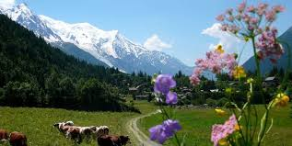
Thursday the 13th June 1969 is a day we will never forget. The sensible advise to anyone buying a caravan for the first time is to start with short trips, practice towing and reversing, gain confidence in carrying your home on your back and read the manuals and magazines before embarking on a long trip.
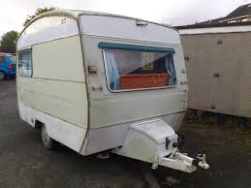
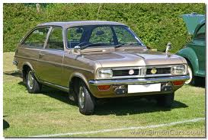
We bought our 10’ 0’’ mobile home, hitched it up to our 1000cc Vauxhall Viva car, brought it home, and two weeks later took it out for the first time – to Switzerland. It was our first trip by road to Europe, but ’no problem driving on the right’, ’towing a caravan is easy enough’, and ‘in any event, anything that could go wrong will not happen to us and the drive down to Southampton to catch the ferry to France will give us all the practice we need’.
After 170 miles of trouble free, if a little slow driving, we reached the South Coast for our overnight sail across the Channel. We had, of course, carefully planned our journey, a good night’s sleep on the boat before a day’s drive through France. Our own cabin on the boat for the night sounded very posh after a relaxing evening meal and duty free drink. Nobody told us that our luxury cabin was in fact a two tier wardrobe with a throbbing vibrating engine under each pillow. Ten minutes after retiring for our deep slumber and dreaming of our holiday to come, we were on deck to escape the claustrophobic wardrobe and to feel the breeze and fresh air on our faces. A long largely sleepless night followed before the coast of France emerged through the morning mist and we finally drove from the bowels of the ferry into the port of Le Havre at 7-00am on Saturday morning.
Think right was now the order of the day, but before that the French customs post. No problems here, we have our passports, green card, AA5 star insurance cover and no duty free goods. The Gendarme (French Policeman) peering through our window seemed friendly enough, it was his humourless colleague standing on the caravan tow bar bouncing the back of the car up and down that concerned us. We willed him not to speak to us as the only French word we knew, or at least could remember at the time was Bonjour and, by the look on his face, that was the last thing he wanted to hear. Eventually the movement of the car stopped and to our relief the documents were returned and we were on our way. ‘Think right’, concentrate, open straight roads, very little traffic and the fact that we had not had to drive through Le Havre itself soon bolstered our confidence. As we beginning to relax and the adrenalin had slowed to a trickle, we reached our first small town. As we approached a crossroads in the centre of the town there were no directional or warning signs, at least none that made any sense to us.
Do we drive straight over, stop, slow down or cover our eyes and hope. At the moment we reached the junction, French vans emerged at speed from right and left. All three of us screeched to a halt on the damp cobbled road and it soon became apparent as they threw their berets at the windscreen that we had done something wrong. We never found out what, except that our anxiety and adrenalin flow was back at maximum level.
From that traumatic point our journey became almost a pleasure and we occasionally had an opportunity to glimpse the scenery marvelling at the site of Chatres Cathedral high on a hill and visible from many miles away.
Next, we approached our first large city, Orleans.
As we changed from a rural to urban landscape, the choice of Centre Ville or Tout Directions was presented to us at the roadside. Centre Ville sounded more appealing and, in any case, we did not know what Tout Direction meant anyway. Ten minutes later we were in four lanes of traffic in a one way street with no idea which lane we should be in to escape at the other end. Thankfully we took the correct turn and soon the sign Orleans with a line through appearing denoting the end of the city and another test passed with honours. We settled down to a more relaxed drive down the beautiful Loire Valley.
By this time the petrol gauge was flickering towards the red zone and the thought of facing another Frenchman filled us with apprehension. After passing as many filling stations as we dared, we finally pulled into a forecourt. A short, thick set, Gauloises smoking Frenchman strolled to the pumps and mumbled something in French, which I assumed meant ‘how much petrol?’. That was the bit I had been dreading. Going to France was fine, meeting an actual Frenchman who could not or would not speak English was something else. My really intelligent gesture was to raise my hand with fingers spread indicating five.
I watched the pump indicator climb to five before offering him a five million franc note to avoid the embarrassment of not giving him enough money. I took the change, returned to the safety of the car and sighed with relief as we drove off – remember to think right of course. Looking at the petrol gauge we were alarmed to see that the petrol gauge had hardly moved. It took a while to realise that 5 was litres to my filling station friend, not the gallons I had intended. The twin ordeal of driving using mental arithmetic to work out how many litres there were in a gallon proved too much as we realised that we had to repeat the experience within the next few miles – or is it Kilometres. Just before dusk and after 12 hours of driving with just one half hour stop, we pulled into a caravan site near the France/Swiss border exhausted but elated that we had crossed France with the minimum contact our fellow human beings. The following day took us into Switzerland through Neuchatel, Berne, the wonderful Bernese Oberland into Interlaken and up the valley to Lauterbrunnen. Idyllic scenery, exciting mountain tops and unbelievable weather intoxicated us. We abandoned our car for the rack railway, cable car and chair lift and we decided to stay until the first day it rained.
We woke early on Thursday 13th June to the sound of rain pattering on the roof of our caravan. Time to hitch up and go. My only previous trip abroad had been as a teenager on a holiday by train to Zermatt. This had left an indelible memory of the most beautiful sight I had ever seen, the Matterhorn mountain against a dazzling blue sky with a foreground of carpets of alpine flowers and bell ringing cows, while breathing wine that was the air. As I wanted Dot to share my memory of the time spent there, that is where we were driving to on the day it rained or at least to Visp in the Rhone Valley, which is at the bottom of the valley leading to Zermatt.
We drove back down the Lauterbrunnen valley to Interlaken, along the shores of Lake Brienz and turned right at the end of the lake, where it indicated Grimsel Pass. 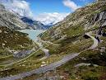
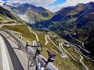
Naive and foolish we may be, but this part of the journey we had researched. The AA Continental Handbook said that the Grimsel Pass was usually open from the end of May. Thursday the 13the June, no problem.

For the first time since we arrived in Switzerland the mountains were shrouded in mist and the relentless swish of our windscreen wipers kept the fine rain at bay. We drove round the end of the lake and then started to climb gently. What scenery we could see was lush and green with the pines standing tall and still. After about 10 minutes a Swiss Mail bus emerged from the thickening mist slowly descending towards us. We were approaching a narrow bridge and we slowed to allow the bus to pass us. As he passed, he waved. Was that a wave of greeting or a wave telling us not to proceed. Dot suggested she knew that he was telling us not to go but cheerfully I said that it was too late to turn back as we would soon be at the top!!.
Gradually the mist thickened, the incline steepened, the trees giving way to a bare rocky landscape and the rain was now sleet. Down to first gear now, must be nearly at the top. Then the realisation dawned that since passing the Mail Bus we had not seen another vehicle, building or living soul. Suddenly any company would be welcome whether or not they could speak English. Our conversation slowed as apprehension grew. The road appeared to rise even higher into the mist with the stone blocks defining the line between the road and the abyss of mist to – we knew not where. Layering snow now covered the landscape and, to our alarm, on the road in front of us. We had now been climbing for about an hour and as the temperature plunged, our little Vauxhall Viva panted and strained with our home for a fortnight following dutifully behind. No gear changes now, it was first gear all the way.
Walls of snow as high as the caravan rose sometimes to the left, then on the right as we spiralled upwards, then on both sides with a thick layer of snow on the road. The fine rain had long been replaced by large snowflakes which, combined with the mist, had reduced visibility to a few yards. If we stop now, we will never get started again I remarked.
Suddenly out of the mist and snow emerged the back of an enormous snowplough shooting snow high into the air like a golden fountain on bonfire night. The sight of something, anything, helped to relieve the great tension we were feeling. Now we know what it feels like to have a minder. As long as he kept going and we stayed close behind we felt safe. As soon as that thought came into our minds our snowplough companion groaned to a halt. We pulled in behind and a few seconds later a short stocky figure appeared. I stepped out of the car and into the snow towards him. My short sleeved teeshirt and open toed sandals seemed a little inadequate for the blizzard conditions we found ourselves in. If I was cold, he must have been hysterical and if he wasn’t when he saw me, he soon would be. We quickly discovered he was Italian and that he wanted us to reverse down the road. As a now experienced caravaner and gaining more experience by the second, reversing down the road would be no problem.
Unfortunately, I underestimated my ability aided by a wall of snow on one side, a sheer drop on the other, and a small Italian who, for some reason, I was beginning to excite. Within seconds his arms were circling like a windmill as he bounced up and down in the snow. Talk about mad dogs and Englishmen. Even mad dogs would have thought twice about the fine mess we had gotten into.
He thought so little of my efforts that he suddenly disappeared back into his snowplough slamming the door as he went. An eyrie silence fell on the scene as the snow quickly obliterated our footmarks and we began to speculate why he had found it necessary to stop his snowplough.
Our Italian friend eventually emerged again obviously desperately trying to control his emotions in a renewed effort to reverse me down the road. A supreme effort by both of us seemed to satisfy him and he again climbed into his cab this time without attacking the door. The enormous machine burst into life and slowly edged forward ever closer to the terrifying drop to our right.
We stayed firmly where he had put us not daring to incur his wrath again. Soon we would see the reason for all the commotion as a vehicle slowly edged down the road coming out of the mist and snow like an apparition in a horror movie. We soon discovered that it was not any old vehicle but an English couple with a car and caravan!!. Suddenly the tension disappeared as we wound down the passenger window to wish our fellow intrepid travellers a Merry Christmas. By now we were all laughing hysterically, good job our small Italian friend could not see us as, by now, he had disappeared up the road.
Now it was back to our first gear climb and within a few minutes we reached the summit over 10,000ft above sea level and to the safety of a hotel car park.
The warmth of the hotel lounge beckoned us as we received more amazed stares from the staff and in particular my tee shirt, open toe sandals, the Vauxhall Viva and caravan. When they realised that we had negotiated the north face of the Grimsel pass they told us that the road had only been open for two days and that we were only the second vehicle to make the journey. A warm fire and an even warmer bowl of soup thawed us out and calmed our nerves.
The journey down the southern face could not have been in greater contrast as we quickly emerged from the mist and snow to once again enjoy the magnificent scenery and security of the Rhone Valley.
Thursday the 13th of June 1969 had certainly been a day to remember and we still had 10 days of our adventure still to experience.
Looking back to that day now over 50 years ago that frightening but wonderful experience could never be repeated now that we have Google, I phones and GPS etc. How great it was to just have the AA Continental Handbook and a sense of adventure.

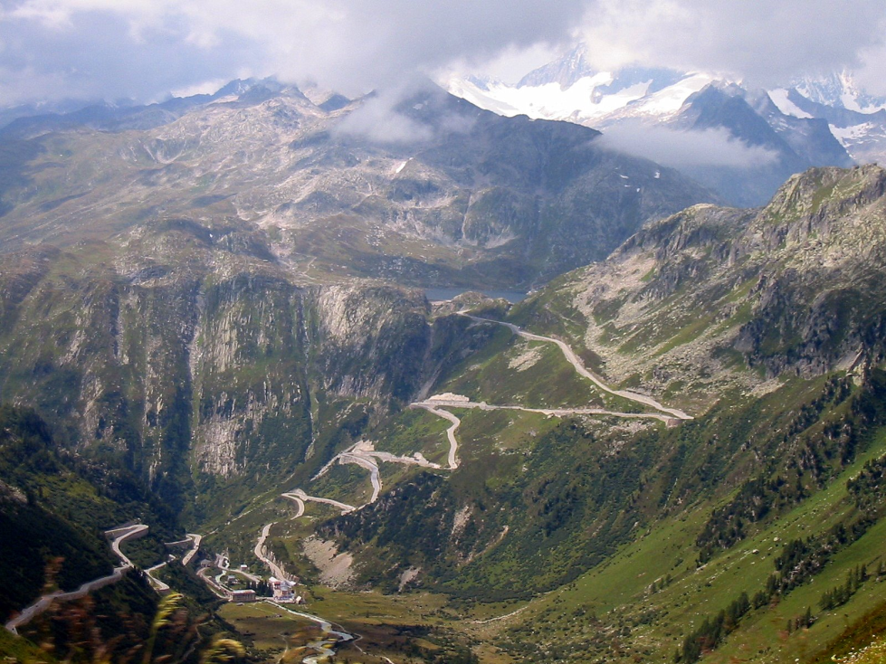
Grimsel Pass, Switzerland

